It is the process of planning and conducting transactions across national borders to create exchanges that satisfies the objectives of individuals and organization

**International marketing concepts:**

Export Marketing, - Exporting Goods

Inter-cultural Marketing – Exchange between two countries

Global Marketing – total world is one world

**EPRG Model:(Basic markets are 4 types)**

Ethnocentric markets - (Domestic market)

Polycentric markets – Several Countries

Regiocentric market,– Regional Market- regions

Geocentric markets – world becomes global village

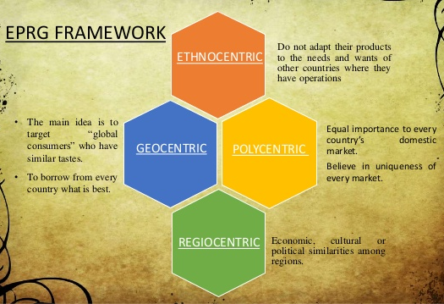

**The Scope and challenge of international marketing:**

International marketing , Intet finance, interna management ((((center )))) International trade

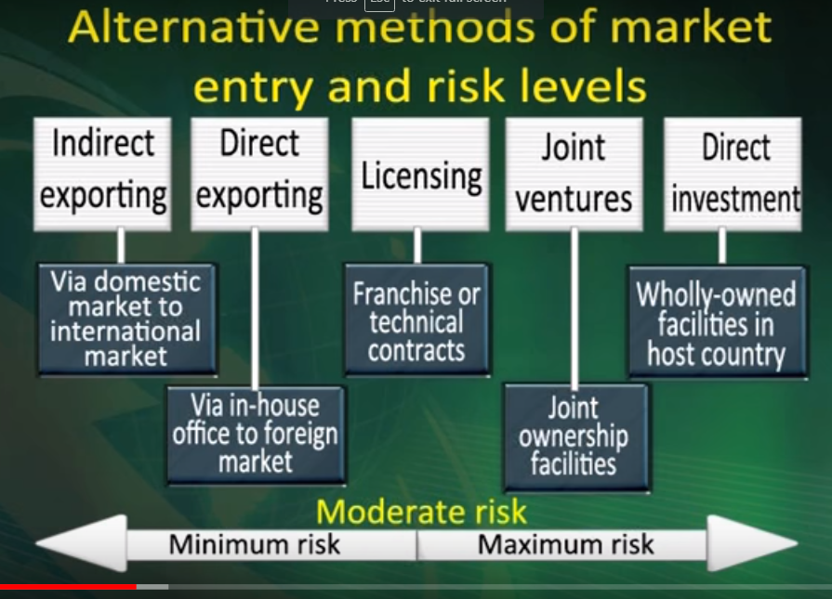

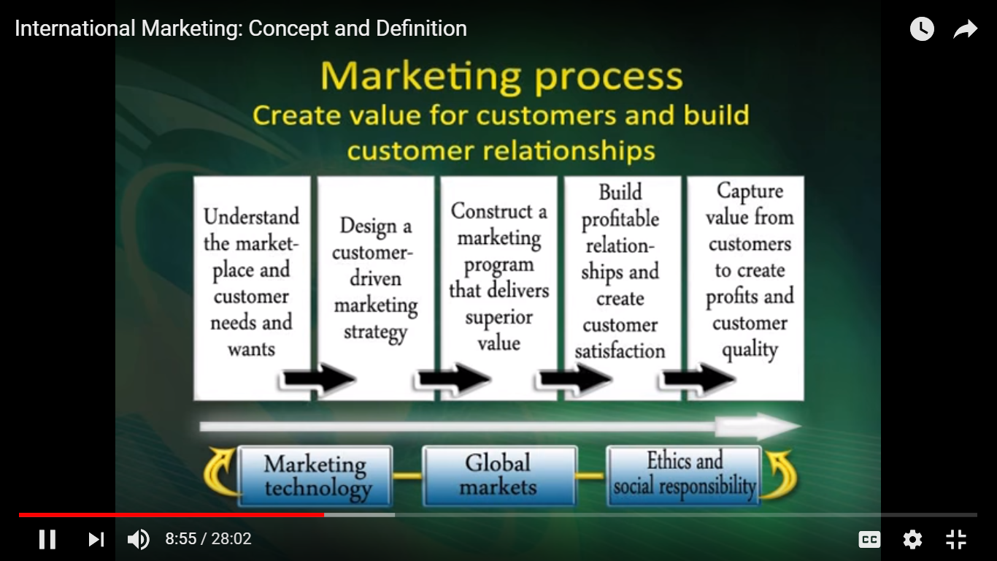

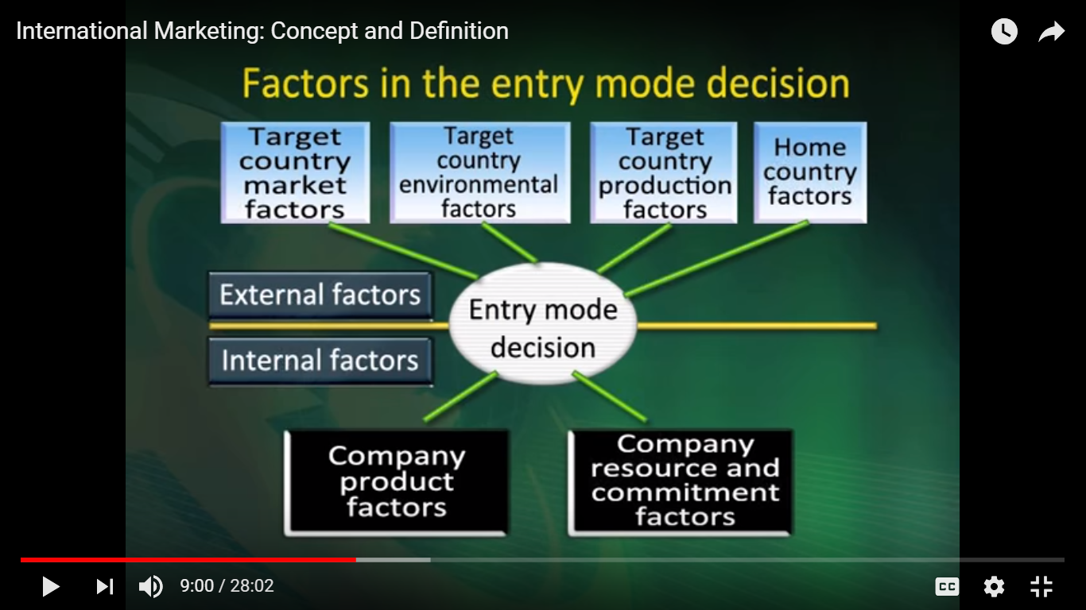

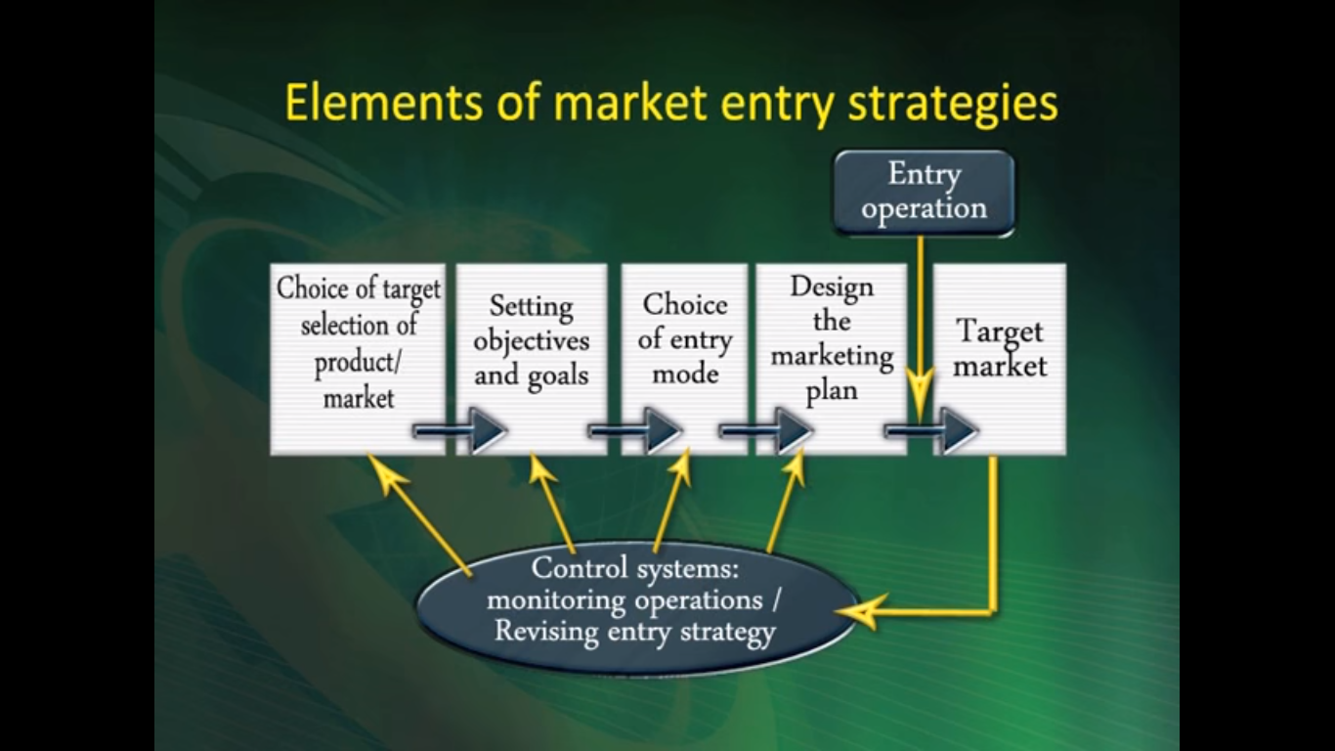

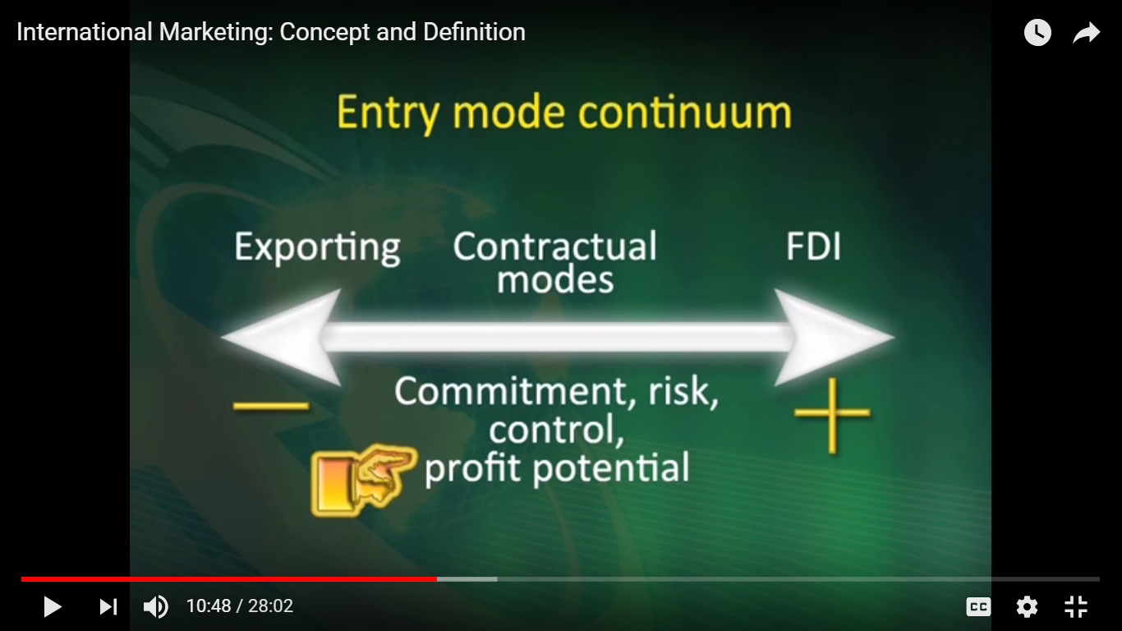

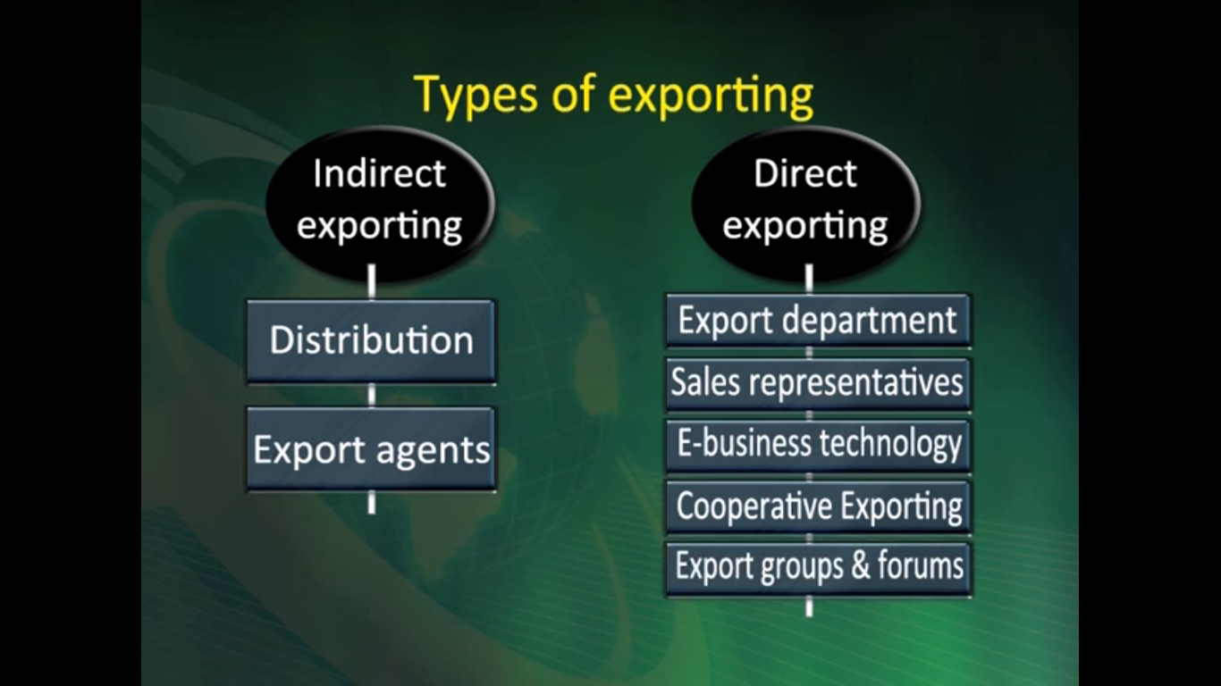

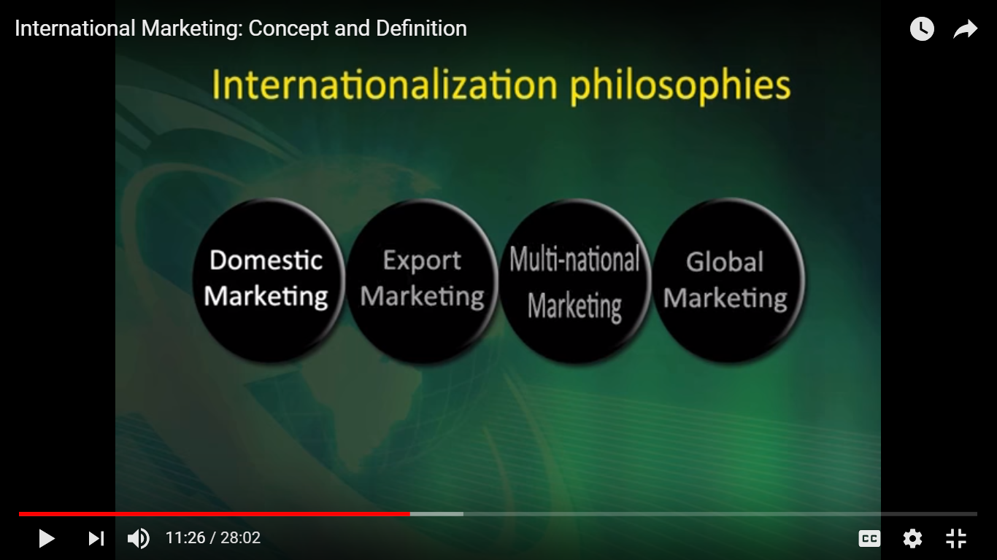

World Market Trends and Future Predictions,

**MKU material:**

* The Demand for Online Marketing Will Continue to Increase
* Cross-Platform Marketing Will Come Into Its Own
* The Content King is Once Again Crowned
* The Rise of Big Data
* The Further Improvement of Analytics
* Internet Marketers Will Move Away From PPC
* Our World Has Gone Mobile
* The Expansion of Local Search

**World Market Trends:**

**Automated translation platforms:**

**International market research:**

**Emerging laws:**

**Changing technologies, new opportunities:**

**Local talent:**

**CMOS and their teams will embrace AI in 2018 - Knowingly or Unwittingly.**Scott Beaumont, President Google Greater China, Google

**The Future of Marketing is About Connection and Content.**

**Information Asymmetry Between Brands and Consumers Will Disappear.**J

**In 2018, There Will Be a Line of Division Between Those Who Can Adapt to Digital Tech and Those Who Can’t.**

**2018 Will Be the First Year of Real AI Marketing.**

**Content will Bring New Challenges and Opportunities for Industry**

**Cross-Sector Marketing will Gain Popularity in the New Year.**

**Marketers Will Continue to Prioritize “New Consumption”.**

**“Growth Hacking” Will Become the Priority for CMOs and CEOs**

**With the Advent of “New Retail,” the Gap between Traditional and E-Commerce Retailers Will No Longer Exist.**

**CMOs Will Spend More Time Figuring Out How to Make Internet Companies More than Their Products.**

**Marketing Mental Models Will Need To Change in the New Year**

**The Top Three Priorities in 2018 Will Shift.**

There are three key aspects that will earn a disproportionate amount of marketers’ attention: 1) **The youth culture**—shifting from niche to mass culture; 2) **More efficient integration and use of big data;** and 3) **Brand security** – building a more honest and safe marketing environment.

**Marketers Will Build More Comprehensive Brands**

**CMOs Will Continue to Focus on Improving the Integration of Data and Content**

**International Market Segmentation**

Explain the segmentation

process?

**Market Segmentation Process:**

**The first step is to determine the**

**boundaries of the market. In**

**completing this step, a marketer**

**should use a formal business plan to**

**develop a broad definition of their**

**business, and then consider the**

**offerings of both direct and indirect**

**competitors to gain information about**

**the basic needs of consumers in the**

**market.**

**The second step in the process is to**

**decide which variables to use in**

**segmenting the market. Many**

**companies**

**fall into the trap of collecting**

**data on as many variables as**

**possible and then attempting to**

**sort through it later to draw**

**meaningful conclusions. Instead,**

**Hiam and Schewe recommend that**

**marketers use their knowledge of the**

**market to select a few relevant**

**variables in advance. This approach**

**is generally less expensive and will**

**likely provide more useful results.**

**The third step in the market**

**segmentation process is actually**

**collecting and analyzing data, which**

**involves applying market research**

**tools. The goal in analyzing the data**

**is to identify market segments**

**that are internally homogeneous, yet**

**are distinctly heterogeneous with**

**respect to other segments.**

**The fourth step is to develop a**

**detailed profile of each market**

**segment, which involves selecting**

**those variables that are most closely**

**related to consumers' actual buying**

**behaviour.**

**The fifth step in the market**

**segmentation process is to decide**

**which segment or segments to serve.**

**In targeting a particular segment, a**

**marketer should look for**

**opportunities (i.e., customers with**

**unsatisfied wants and needs) that**

**provide a good match for the**

**organization and its resources.**

**It is important that the marketer**

**consider not only the size and**

**potential profitability of a market**

**segment, but also whether the**

**company's skills, technologies, and**

**objectives would enable it to meet**

**the needs of that segment better**

**than its competitors. The sixth and**

**final step is to develop a product**

**and marketing plan that will**

**appeal to the selected market**

**segment. This involves identifying the**

**product attributes that are most**

**important to consumers in the**

**segment, and developing a marketing**

**strategy that will attract their**

**attention. In fact, market**

**segmentation can be usefully applied**

**during the earliest stages of**

**product design, when a company first**

**identifies who its target customer will**

**be in terms of demographic,**

**geographic, and behavioral**

**characteristics.**

[**https://strategyn.com/outcome-driven-innovation-process/market-segmentation/market-segmentation-process/**](https://strategyn.com/outcome-driven-innovation-process/market-segmentation/market-segmentation-process/) **take**

**DIFFERENDIFFDIFFERENCE BETWEEN MARKET**

**SEGMENTATION & TARGET**

# Discuss the Difference between Market Segmentation & Target Marketing

<https://smallbusiness.chron.com/discuss-difference-between-market-segmentation-target-marketing-1480.html>

**https://www.tutorialspoint.com/cgi-bin/printpage.cgi**

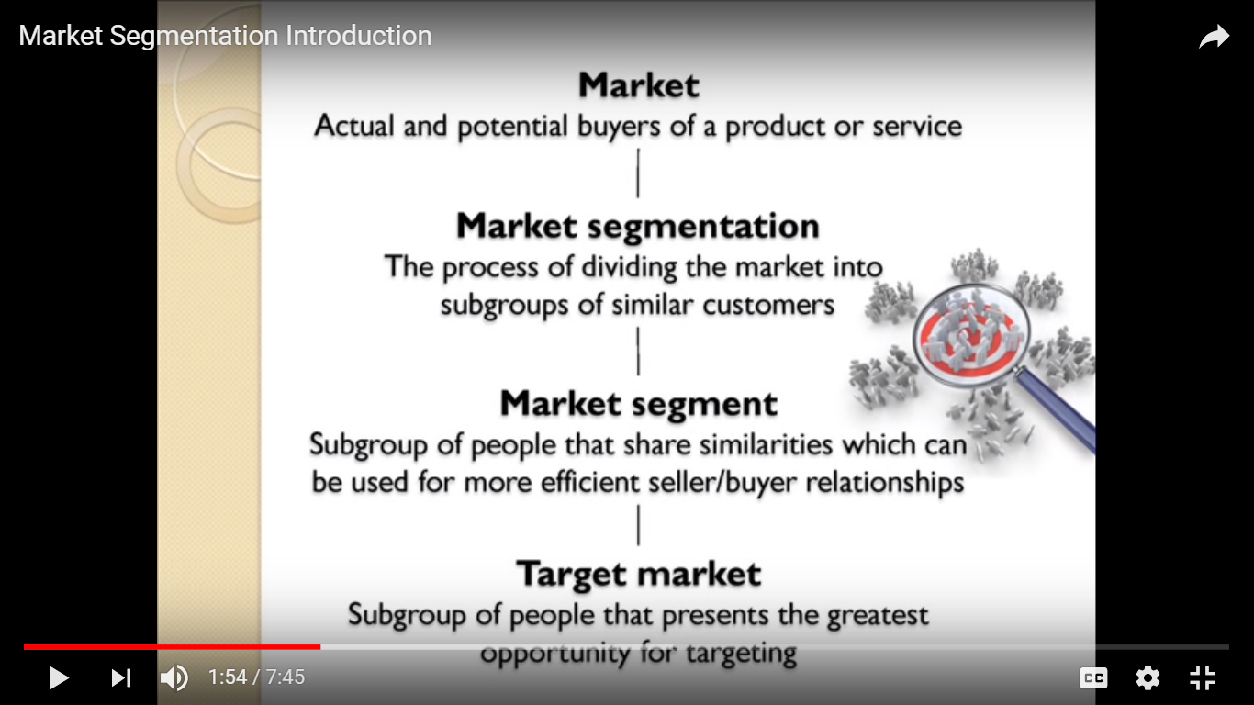

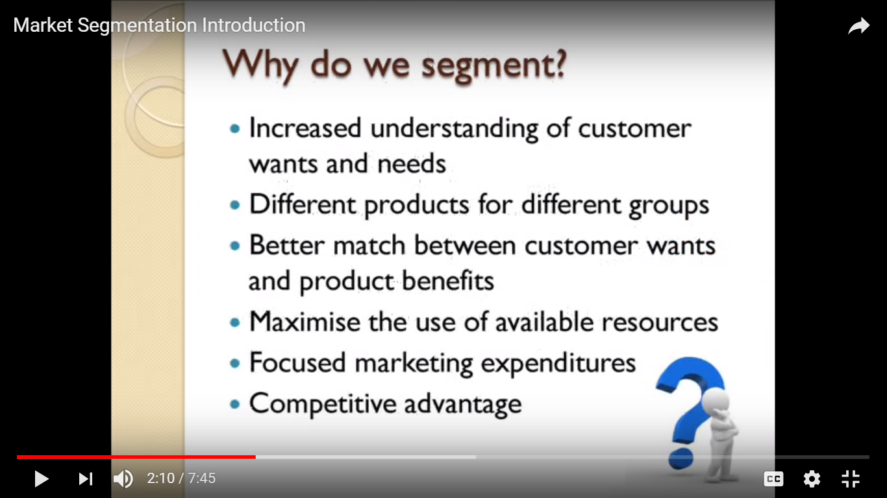

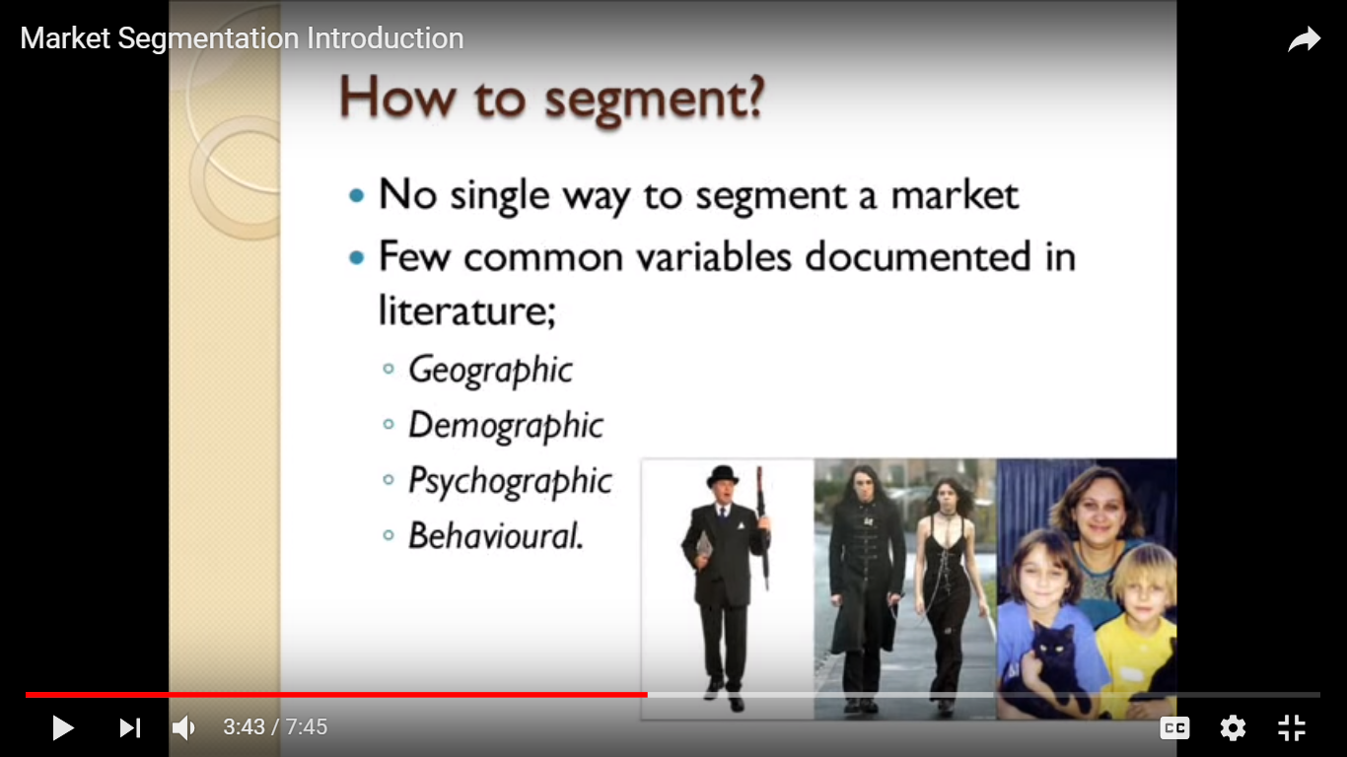

**\**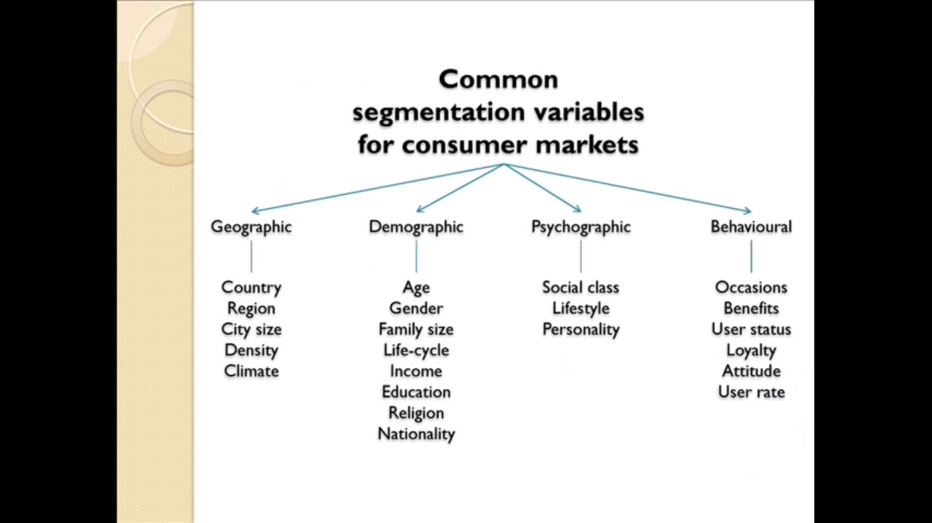

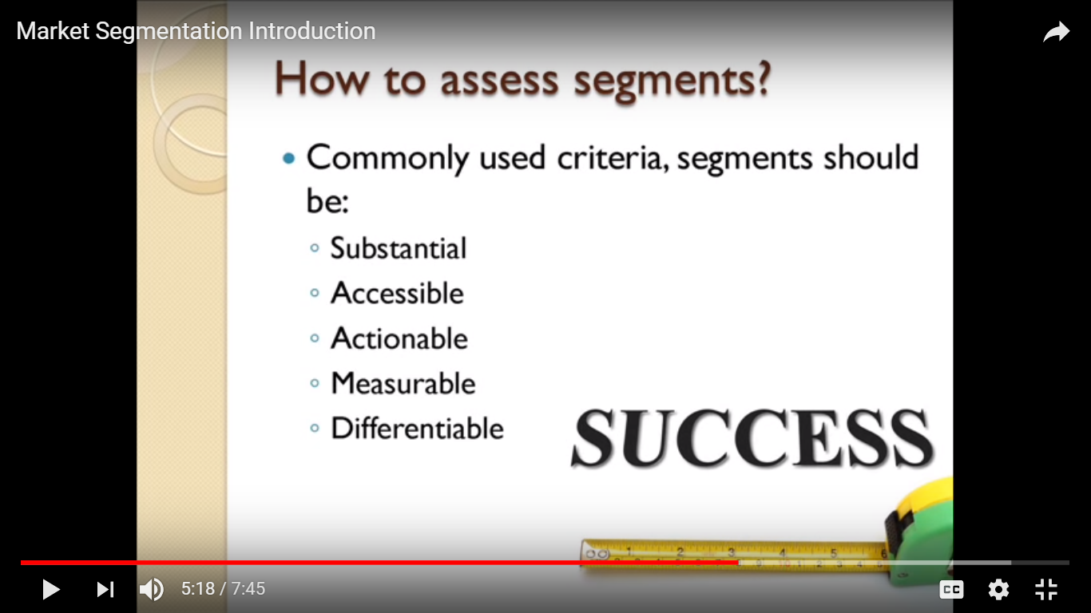**\**

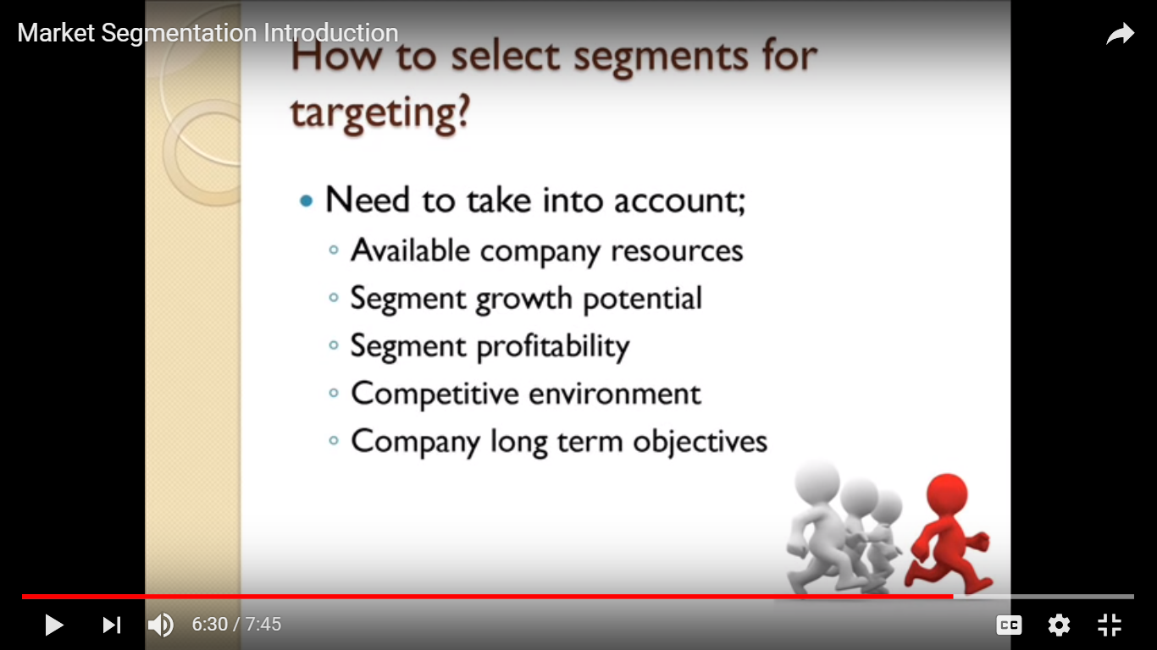

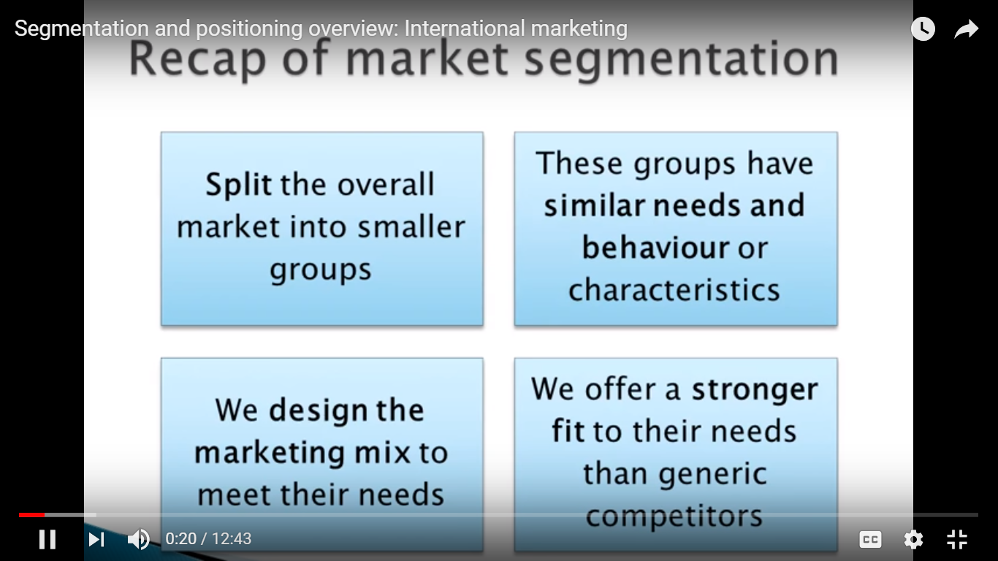

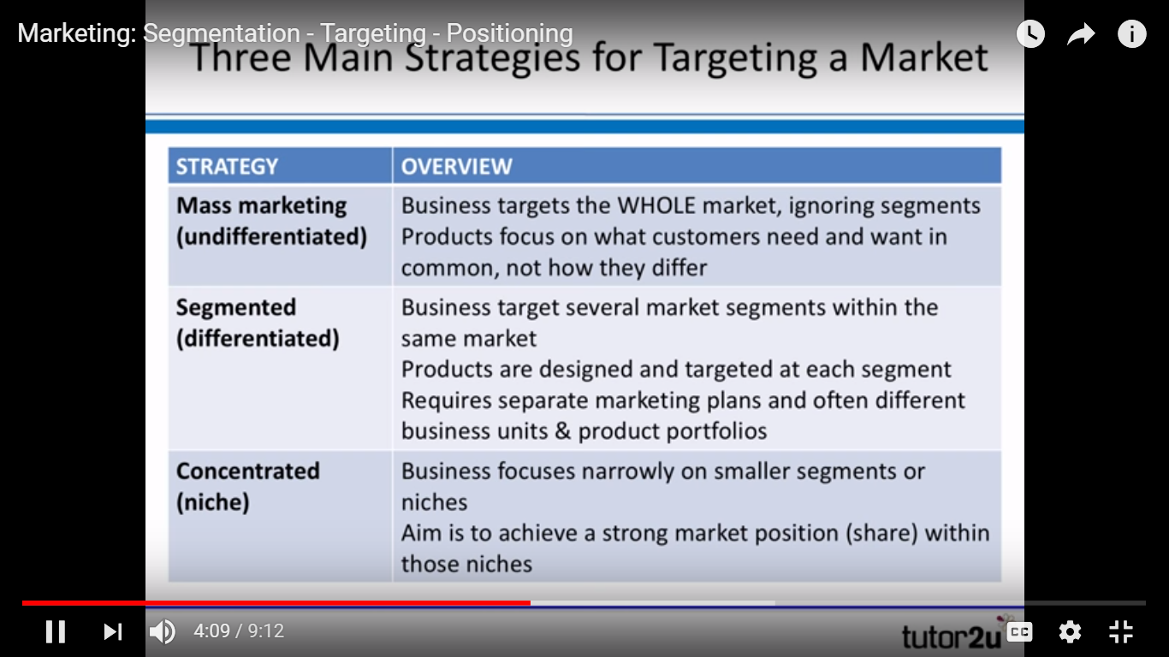

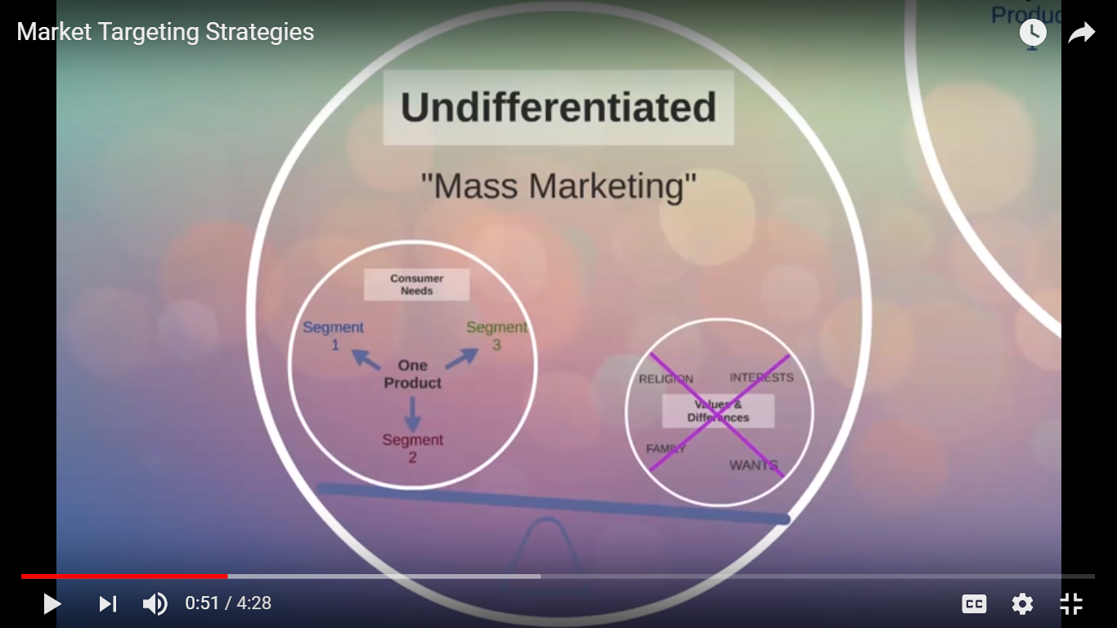

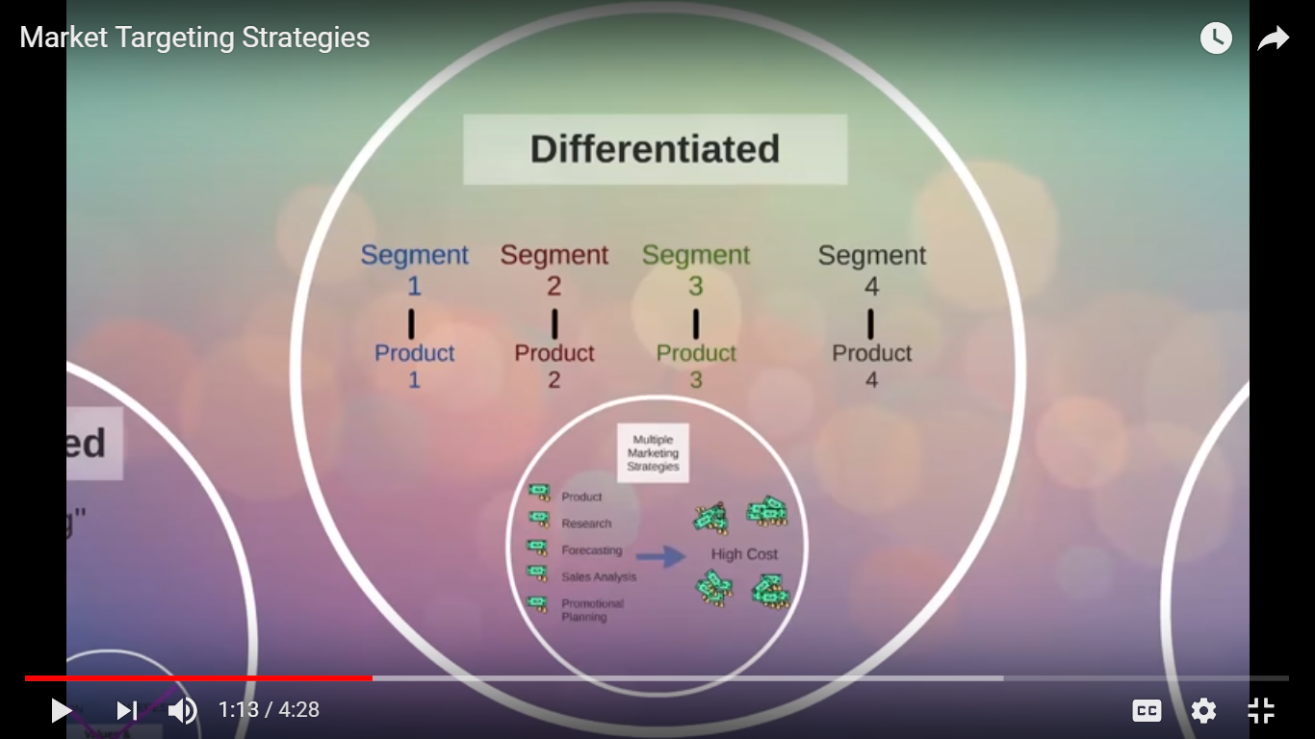

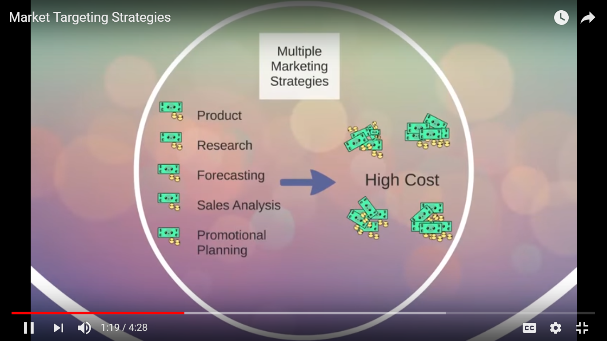

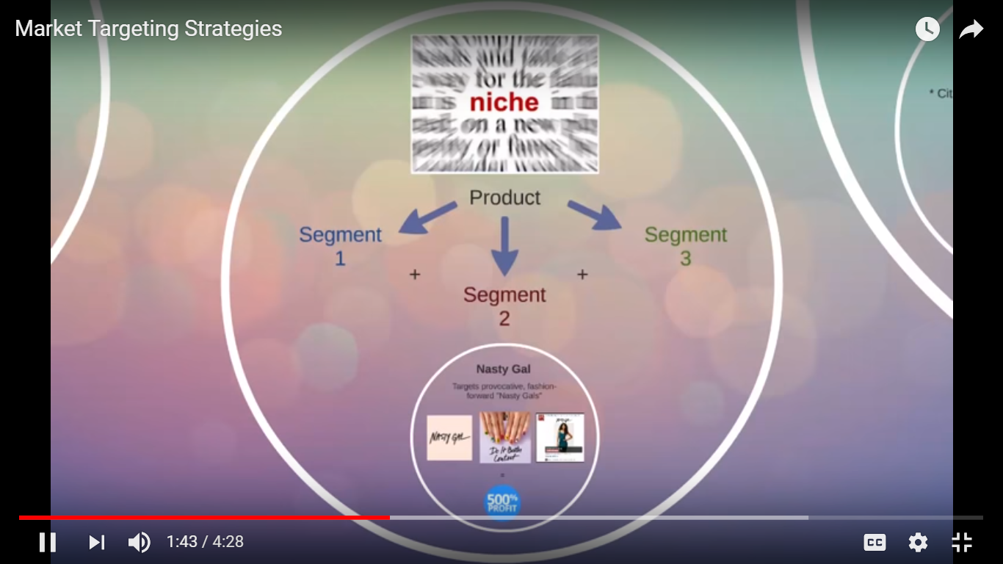

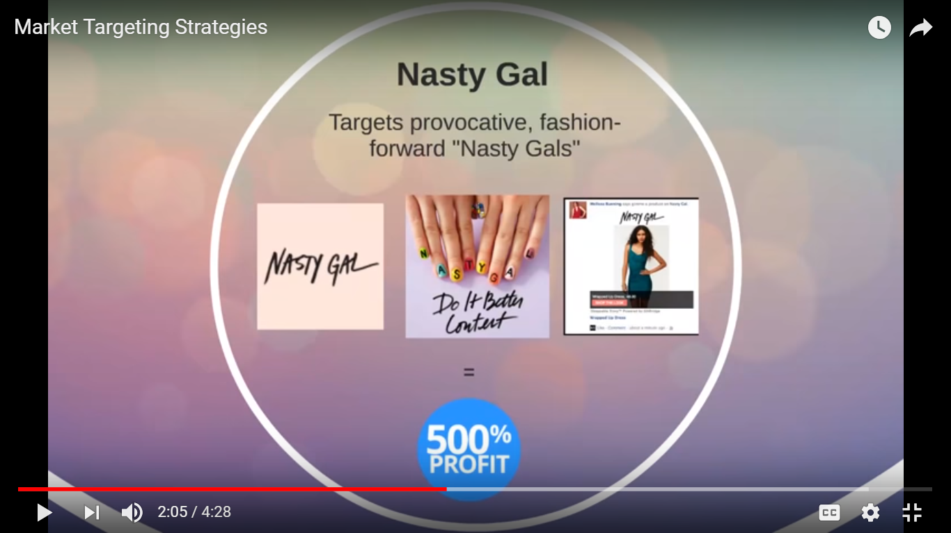

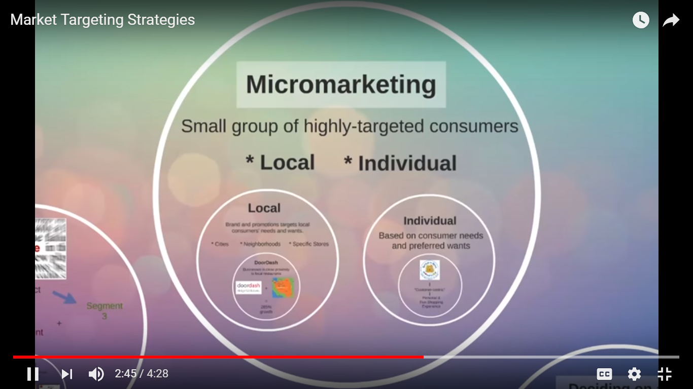

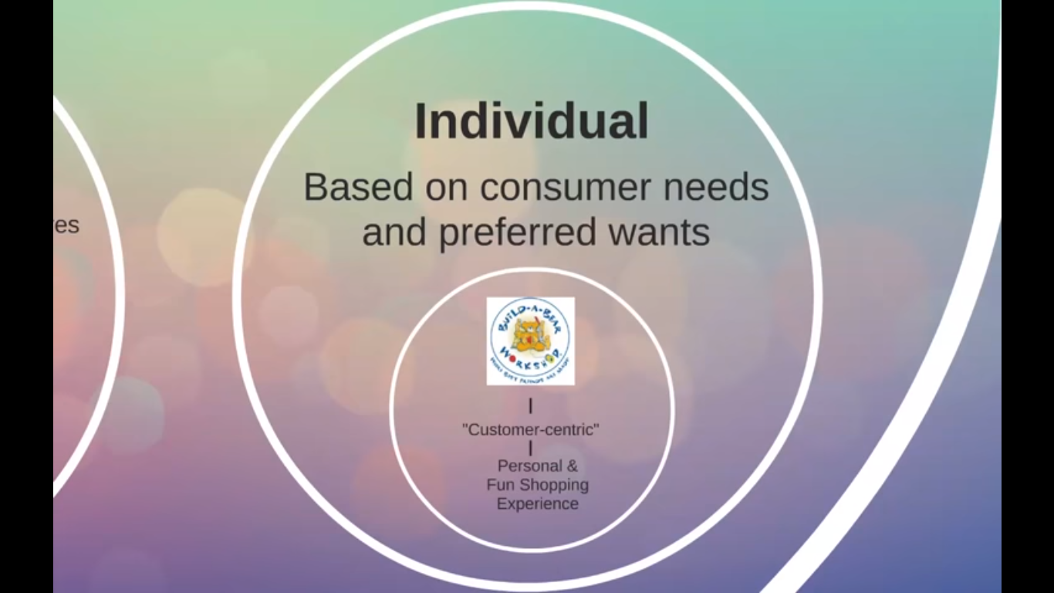

**How to evaluate the market segmentation?**

**Market segments can be evaluated on the following criteria;**

**A. Segment Size & Growth**

**B. Segment's Structural Analysis**

**C. Competition Within The Segment**

**D. Existing Or Potential Substitute Products**

**E. Relative Power Of Buyers / Suppliers**

**F. Company's Objectives & Resources**

**G. Environment, Social Responsibility, If It Is Core Business, Can Employ Skills & Resources Superior To Those Of Competition.**

**How to evaluate the market segmentation?**

**Cultural Dimension of International Marketing:**

**Edward Taylor:**

**McDonald's varies based on the location of the restaurant**

**International Markets Selection**

**Pending:**

**International marketing process**

**IM evaluation.**

**5 steps of IM**

**Other:**

E-commerce – Internet

Stylish economy

Digital transformation

Territorial

Question and answer:

1. What is market segmentation?

2. Explain the process of segmentation?

3. What is target marketing?

4. Discuss the concept of international target marketing?

5. What are the difference between target market and market segment?

6. How to select international market segment?

*****************************End of 1 ********************************

*****************************Start of 2 *******************************

**PRODUCT CONCEPT**

1. **Explain the International product concept?**
   1. **The Production Concept.**

The basic proposition of the production concept is that customers will choose [products and services](https://www.marketing91.com/difference-between-goods-and-services/) that are widely available and are of [low cost](https://www.marketing91.com/cost-based-pricing/). So business is mainly concerned with making as many units as possible. By concentrating on producing maximum volumes, such a business aims to maximise [profitability](https://www.marketing91.com/profitability-analysis/) by exploiting [economies of scale](https://www.marketing91.com/economies-scale/).

Managers try to achieve higher volume with low cost and [intensive distribution](https://www.marketing91.com/intensive-distribution/) [strategy](https://www.marketing91.com/marketing-and-strategy-models-and-concepts/). This seems a viable strategy in a developing market where [market expansion](https://www.marketing91.com/product-market-expansion-grid/)is the [survival](https://www.marketing91.com/new-product-development-necessary-survival/) strategy for the business. Companies interested to take the benefit of scale economies pursue this kind of [orientation](https://www.marketing91.com/customer-orientation/).

* 1. **The Product Concept.**
     1. The product concept holds that the consumers will favor products that offer the most in quality, performance and innovative features.
     2. Marketing strategies are focused on making continuous product improvements.
     3. Product quality and improvement are important parts of marketing strategies, sometimes the only part. Targeting only on the company’s products could also lead to marketing myopia.
  2. **The Selling Concept.**
     1. The selling concept holds the idea- “consumers will not buy enough of the firm’s products unless it undertakes a large-scale selling and promotion effort”.
     2. Here the management focuses on creating sales transactions rather than on building long-term, profitable customer relationships.
     3. For instance,**insurance**
  3. **The Marketing Concept.**
     1. The marketing concept holds- “achieving organizational goals depends on knowing the needs and wants of target markets and delivering the desired satisfactions better than competitors do”.
     2. Here marketing management takes a “customer first” approach.

## Difference between Selling Concept and Marketing Concept

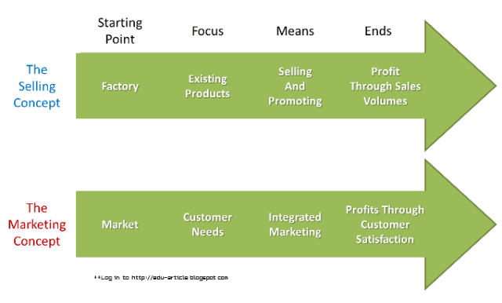

|  |  |  |
| --- | --- | --- |
| **No.** | **The Selling Concept** | **The Marketing Concept** |
| 1 | undertakes a large-scale selling and promotion effort | undertakes activities such as; market research, |
| 2 | The Selling Concept is suitable with unsought goods—those that buyers do not normally think of buying, such as insurance or blood donations. | The Marketing Concept is suitable for almost any type of product and market. |
| 3 | Focus of the selling concept starts at the production level. | Focus of the marketing concept starts at understanding the market. |
| 4 | Any company following selling concept undertakes a high-risk | Companies that are following the marketing concept requires to bare less risk and uncertainty. |
| 5 | The Selling Concept assumes –“customers who are coaxed into buying the product will like it. Or, if they don’t like it, they will possibly forget their disappointment and buy it again later.” | Instead of making an assumption, The marketing concept finds out what really the consumer requires and acts accordingly to them. |
| 6 | The Selling Concept makes poor assumptions. | Marketing concept works on facts gathered by its “market and customer first” approach. |

## [Societal Marketing](https://iedunote.com/societal-marketing-concept)Concept

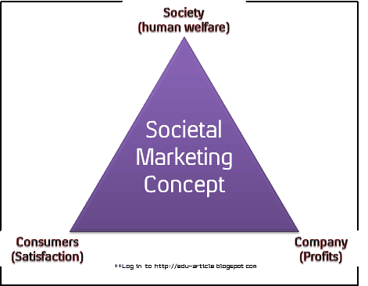

[**Societal marketing concept**](https://iedunote.com/societal-marketing-concept) questions whether the pure marketing concept overlooks possible conflicts between consumer short-run wants and consumer long-run welfare.

The societal marketing concept holds “marketing strategy should deliver value to customers in a way that maintains or improves both the consumer’s and society’s well-being”.

**\*\*\*\*\*\*\*End of International product concept \*\*\*\*\*\*\*\*\***

1. Standardization of Product?

The three principal advantages generated by standardising the product are the following:

• cost economies

• consistency amongst consumers

• simplification of planning and Control

1. Adapting a product
2. Product Adoption Vs Product Standardization,

product Life Cycle?

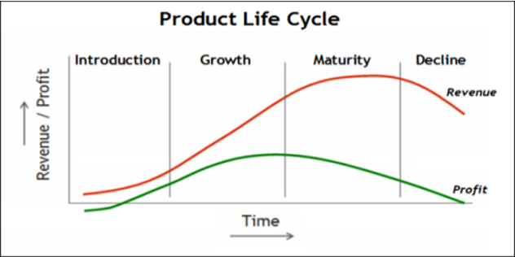

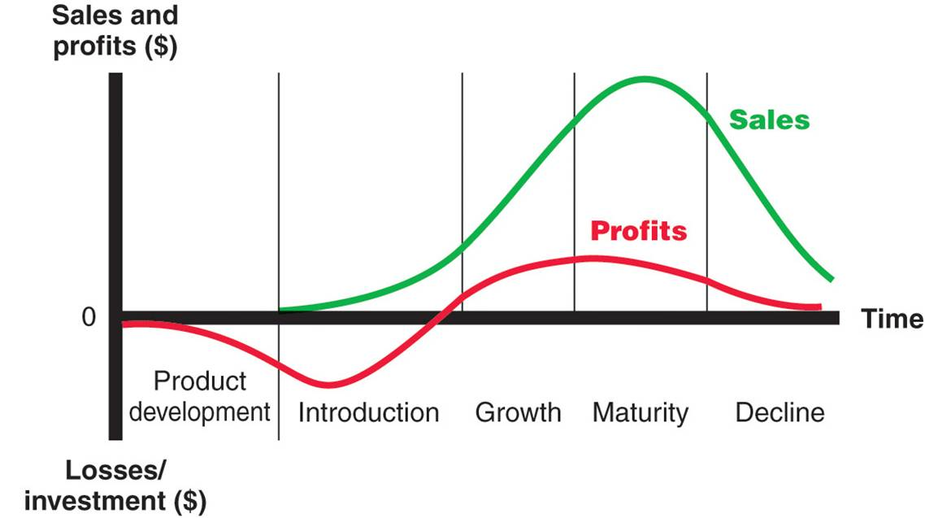

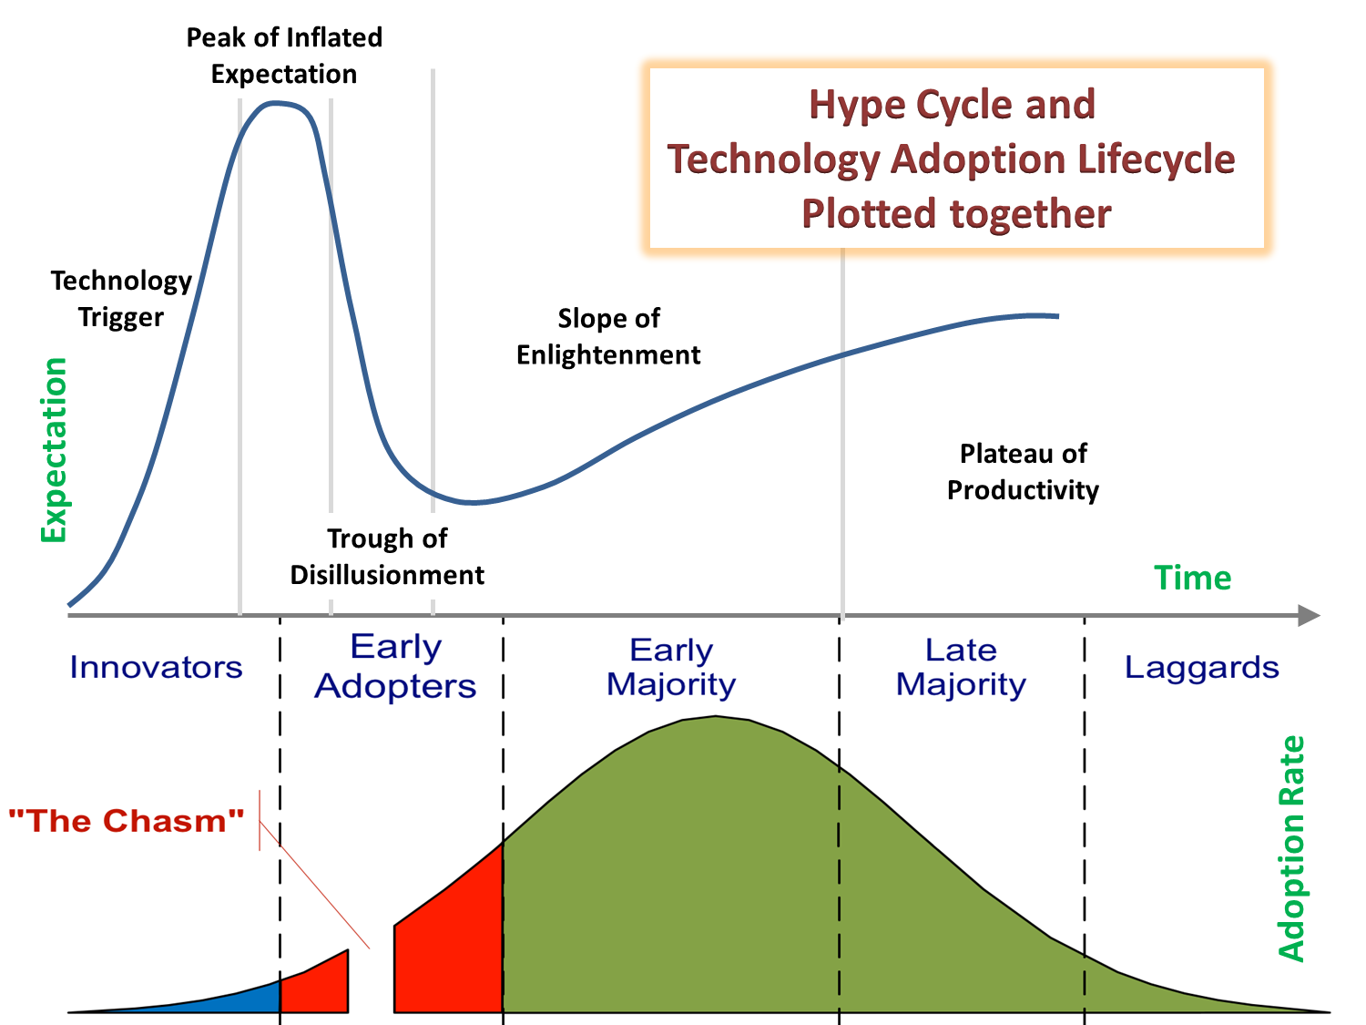

Questions:

1.Explain the various concept in international product?

2. What is standardization of product?

3. What is adaptation of a product?

4. Explain the international product life cycle?

5. Describe the product life cycle in international marketing?

**Nature of Product Positioning:**

**Purpose of Product Positioning:**

**Basic Product Positioning Process.**

What are the benefits of product positioning?

**Premiums**

**Branding**

**Category Claims**

**Differentiation**

Product positioning strategies:

1. Explain the international

product strategy?

**International product strategies:**

Standardization of product strategies strategies

1. Standardization means offering a uniform product on regional or

worldwide base may be with minor changes.

2. Customization leverages crossborder differences in needs & wants of the firm's target customers.

3. Forces that favor a globalized product strategy are:

4. Common customer needs & buying behavior

5. Economies of scale in production, R&D, marketing and cost savings

6. Lesser time required in introducing into new markets

7. Global consumers & consumer mobility

8. Home country image

9. Similar technical specs for industrial & consumer products

10. Operating via exports of uniform products

11. Better marketing performance

12. Consistency in product design & selling techniques

13. Establishes a common image

14. Success in one market can be duplicated in other markets

15. Standardization may lead to substantial opportunity lost

**Adaptation of product strategies:**

1. Obligatory adaptation due to

laws and regulations of foreign

countries

3. To better suit varying customer

needs

4. Differing use conditions

5. Due to different market factors

6. Company's resources / product

objectives

7. Product life-cycle stage

**Here are ten recommendations for a successful global brand launch.**

strategy?

3. Explain the international product

strategy?

4. Explain how to launch

international brand?

5. Describe the steps to manage

brand?